Paper One
Regenerative Agriculture: Context, Definitions and Drivers of Change

This Document

This document is one of three written for The GREAT Project to build a narrative for a regenerative farming future and to signpost readers to sources of inspiration, evidence and support.
- Paper 1 - Regenerative Agriculture: Context, Definitions and Drivers of Change
- Paper 2 - Regenerative Agriculture: Key Stakeholders at Global, UK and County Level
- Paper 3 - Regenerative Agriculture: Case Studies, Data Sets and Other Useful Information
The GREAT Project

The GREAT Project (The Gloucestershire Regenerative Environmental Agricultural Transition Project) is a collaborative three-year initiative (2020 – 2024) led by the Farming and Wildlife Advisory Group SouthWest working with a range of key local partners including:
- FarmED - The Centre of Farm and Food Education in the Cotswolds
- RuraLink
- Royal Agricultural University - School of Business and Entrepreneurship
- Pasture Fed Livestock Association
- CSA Network
- Gloucestershire Wildlife Trust

We believe that a secure and regenerative food system begins at ground level. It begins with the soil, and the farmers and growers that seek to build a livelihood from it.

With funding support from the Thirty Percy Foundation, we are working to deliver three high impact interconnected work streams focusing on building evidence, sharing knowledge and nurturing enterprise in the regenerative agriculture sector.

Overture

The ‘green revolution’ of the 20th century fed a growing global population at a time of need. It sought and delivered efficiency and safe, affordable food for many. But the food system that emerged was, and remains, inherently depletive - extracting value from our soils, habitats, and landscapes. It is a system based on the exploitation of fossil fuels and other natural resources. It is a significant contributor to climate change and pollution. It has also not been all positive for farmers, the rural economy or the disconnected consumer either. Specialisation, intensification and commodification ultimately benefits corporate growth and shareholder value over natural and social capital.

What does the future of farming and food look like? It is clear that the original concepts of preservation, conservation and sustainability, protecting what we currently have, are no longer enough. Despite the plethora of policies and programmes, and billions of pounds of agri-environment and rural development funding in recent decades, nearly all global environmental, economic and social metrics linked to farming and food remain negative. We must do something radically different.

A successful transition is possible, but we must think and move to a space beyond sustainability. We must move at pace to a position of regeneration – rebuilding, enhancing, and improving. That’s where regenerative agriculture (RA) comes into play.

The Origins of Regenerative Agriculture

Definitions

The term regenerative agriculture and the principles within, are not new. However, there is not one definition and there are contentions. Different definitions stem from different origins and lineages, and they are often linked to their location where they are practised. Definitions include:

“a system of farming principles and practices that increases biodiversity, enriches soils, improves watersheds, and enhances ecosystem services” (Terra Genesis International, 2020)

“a long-term, holistic design that attempts to grow as much food using as few resources as possible in a way that revitalizes the soil rather than depleting it, while offering a solution to carbon sequestration” (Rhodes, 2017)

“a form of enterprise that incorporates a community of people engaged in civil labour to produce and consume the food (and land, landscape and amenity) that they, collectively, decide to grow” (Ravenscroft et al., 2013)

Consensus is mounting for a single, standardised definition. In 2017 The Carbon Underground initiative asked industry leads in the USA to support the following:

‘’Regenerative Agriculture describes farming and grazing practices that, among other
benefits, reverse climate change by rebuilding soil organic matter and restoring
degraded soil biodiversity – resulting in both carbon drawdown and improving the water
cycle’’ (Deans, 2017)

Within The Great Project we see regenerative agriculture as:

Farming principles and practises that increase biodiversity, build better soils, improve water catchment and enhance nutrient cycling, with the aim of capturing carbon in the soil and increasing aboveground biomass; thereby helping to reverse the current global trends of atmospheric accumulation.

The farm business benefits of a regenerative system are diverse. Success can offer good yields from lower inputs and costs, better animal welfare, resilience to climate instability, and healthier and happier farming communities. The food produced from a regenerative system can be more nutrient dense and tastier. Looking beyond the farm gate, a broader and deeper agroecological regenerative approach can also involve the rebuilding of landscapes, more community engagement, new routes to market, localised food systems, and the stimulation of rural enterprise. RA is full of hope.

This paper attempts to unpack the origins and metamorphosis of the term and movement.

Regeneration – At the Heart of Indigenous Culture

Regeneration may be the latest buzzword but indigenous communities across the globe, from the Iroqouis to the Aztecs, followed regenerative principles from the day they first moved from hunter gatherers to farmers of land. Farming in harmony with nature and connection to the soil is at the heart of small-scale farming and indigenous culture.

As we work our way through the current challenges and agricultural transition we should remember to acknowledge our debt to indigenous farmers and give thanks for the food growing practises and ecological wisdom that they have given us. Always look back before looking forward!

The Birth of the Organic and Biodynamic Movements

Rudolf Steiner (1861-1925) was an Austrian philosopher, scientist and social reformer who sought to extend scientific research beyond the existing parameters of natural science and investigate the non-physical, spiritual realities of life. Steiner inspired new approaches to medicine, education, the arts, social reform and economics as well as agriculture. His agricultural lectures, given in 1924 to groups of over a 100 farmers and landowners, gave novel insights and suggestions on how to regenerate and improve agriculture, which led to the foundation of the biodynamic and organic movements. Find out more about biodynamics here.

‘’The health of soil, plant, animal and man is one and indivisible." - Albert Howard, 1947

One book from this time that had a most profound influence was An Agricultural Testament (first published in 1940) by Sir Albert Howard (1873 - 1947). Howard was an English botanist and pathologist working in India, who observed the value of compost applications to soil, crop health and yield. He was a principal figure in the early organic movement with Eve Balfour (1898 - 1990). Lady Balfour helped form The Soil Association in 1946, following publication of her bestselling book about organic agriculture, The Living Soil (1943).

The Rodale Institute – Building The Regenerative Organic Approach

Robert Rodale (1930-1990) son of American organic pioneer J.I. Rodale (1898 - 1971) coined the term regenerative agriculture in the 1970s to distinguish the kind of farming that goes beyond being sustainable. He stated that regenerative organic agriculture “takes advantage of the natural tendencies of ecosystems to regenerate when disturbed. In that primary sense it is distinguished from other types of agriculture that either oppose or ignore the value of those natural tendencies. Regenerative organic agriculture is marked by tendencies towards closed nutrient loops, greater diversity in the biological community, fewer annuals and more perennials, and greater reliance on internal rather than external resources.’’ (Rodale, 1987).

You can read more about The Rodale Institute and their work here.

Robert Rodale outlined seven tendencies that define and conceptualise a regenerative system. Note that these tendencies are aimed at farming as well as communities and personal spirit. Regenerative agriculture doesn’t exist in a silo – we must not forget this if we are to succeed.

1. Pluralism
- Increase in diversity of plant species
- Increase in diversity of business, people, and culture
- Increase in diversity of personal experiences, capacities, opportunities and openness to new experiences.

2. Protection
- More surface cover of plants, ending erosion and increasing beneficial microbial populations near the surface
- More resistance to economic and cultural fluctuations because of quantity and variety of businesses and people, which increases overall employment and community stability
- Improvement of personal hardiness and an ability to withstand crisis, accompanied by a boost in the body’s immune system

3. Purity
- Without chemical fertiliser and pesticide use, a greater mass of plants and other life exists in the soil
- Without pollution of the environment, more people can exist in better health
- By ending detrimental habits such as smoking or thinking negatively, the potential for growth, happiness, and success increases

4. Permanence
- More perennials and other plants with vigorous root systems begin to grow
- As businesses and individuals become successful and stable, they can contribute more to the community
- New, more positive, personal spiritual behaviours take root and provide a deeper meaning to life
5. Peace
- Past patterns of weed and pest interference with growing systems are disrupted
- Former patterns of violence and crime are reduced, improving overall security and well-being
- Negative emotions such as anger, fear, and hate lessen in intensity and are replaced by tolerance, compassion, and understanding

6. Potential
- Nutrients tend to either move upward in the soil profile or to accumulate near the surface, thereby becoming more available for use by plants
- “Trickle up” economics – more resources and money accumulate and are more available to more people
- The positive qualities and resources in yourself and your environment become easier to access and affect more people around you

7. Progress
- Overall soil structure improves, increasing water retention capacity
- Overall community life improves, increasing the health and wealth of its inhabitants
- Capacity for well-being and enjoyment increases

Richard Harwood, Director of the Rodale Research Centre published an International Overview of Regenerative Agriculture in 1983 (Harwood, 1983). This was one of the first formal reviews of RA and its potential. It has been a slow but important burn since then.

Conservation Agriculture – Regen Lite?

Conservation Agriculture is a resource-focused concept that aims to achieve production intensification and high yields while enhancing the natural resource base through compliance with three interrelated principles:

- Maintenance of a permanent soil cover
- Minimum soil disturbance
- Diversification of plant species

The origins of Conservation Agriculture can be traced back to the dust bowls of Midwest USA in the 1930s and the battle to protect degraded soils by reducing tillage. It is rooted in economic and environmental desperation.

The basic principles gained traction across the major arable farming nations over the following decades as technology improved, fuel prices increased and soil erosion/desertification took its toll. Conservation agriculture can be seen as the lite version of the regenerative agricultural movement that we see today.

According to the Food and Agriculture Organisation (FAO), Conservation Agriculture is being practised on around 125 million hectares with the major practising countries being the USA (26.5 M ha), Brazil (25.5 M ha), Argentina (25.5 M ha), Canada (13.5 M ha) and Australia (17.0 M ha). It is promoted widely across Africa (FAO, 2012).

Permaculture – Regenerative by Design

Good permaculture systems are regenerative by design. While more suited for smaller mixed horticultural enterprises, the design framework and ethics of people care, fair share and earth care, can inform larger scale farming operations too.

The concepts of permaculture were developed in the 1970s by growers Bill Mollison and David Holmgren in Australia. Originally the term was a contraction of “Permanent Agriculture” i.e., the design and implementation of permanent (sustainable) agricultural systems. Systems designed in this way tend to have closed energy and resource cycles, being modelled on natural ecosystems and thus requiring minimal primary inputs such as fossil fuel, pesticides or artificial fertilisers.

A designed permaculture system should have a high degree of inter-linkage with ‘waste’ outputs from one part of the system being used as inputs for another part. This is hard to achieve in simple (single output) monoculture-based systems, which is why permaculture design tends to produce multi-layered, complex and highly interlinked systems, echoing nature.

Regenerative Agriculture Today

BASE-UK

BASE-UK was founded in 2012 and is a farmer led knowledge exchange organisation for individuals interested in conservation/regenerative agriculture and passionate about the sustainability, health, and growth of soil. BASE stands for Biodiversity – Agriculture - Soil – Environment. Find out more about BASE here.

The group follows the principles which are fundamentally about carbon management and health in soil based on 3 core principles:

- Minimum soil disturbance.
- Residue cover on the soil.
- Rotations.

Holistic Management – More Than Regenerative Grazing Practice

The role of grazing livestock is an important element within most definitions and forms of regenerative agriculture. Practitioners aim to use farmed ruminants (cattle and sheep) to mimic the activity of wild herbivores in the landscape, stimulating water, soil and nutrient cycling and ecosystem improvements.

Allan Savory, via his original observations in South Africa in the 1960s/70s and latterly across the globe, developed the concept of Holistic Management, seeking regeneration of soils, increased productivity and biological diversity, as well as economic and social well-being. It’s more than just mob grazing. In the UK and Ireland, 3LM (Land and Livestock Management for Life) works as the Savory Hub, offering training, consultancy, accreditation and verification in holistic management. Read more here about the Savory Institute and the 3LM network.

The Challenge of Landscape – Keyline Concepts

The Keyline Scale of Permanence is a concept first outlined in 1958 in The Challenge of Landscape — The Development and Practice of Keyline by P.A. Yeomans (1905-1984), an Australian mining and agricultural engineer. Yeomans, working with the Scottish-Australian geographer James Macdonald Holmes (1896-1966), promoted keyline ploughing following the harmonic patterns of the landscape, based on the natural contours of the land. The use of a non-inversion Yeomans plough gently lifts and de-compacts degraded soil to allow better water penetration and aeration. The four components of keyline design are:

- Rapid soil development
- Water management
- Integrated tree crops
- Rotational grazing

The keyline principle has been adopted by many regenerative farmers and growers across the globe and is particularly suitable for those in dry and brittle environments.

Integrated Farm Management

Integrated Farm Management (IFM) is a site-specific farm business approach that combines modern technology and traditional methods. It is an approach fostered by LEAF (Linking Environment And Farming) since 1991, alongside farm access/education and demonstration. LEAF accredited produce is identified by the LEAF Marque logo. See here for more information.

In 2020, LEAF worked with 873 businesses in 21 countries covering a global area of 299,185 hectares representing 270 different crop classes. The horticulture and arable sectors are the two largest LEAF Marque crop areas worldwide at 153,791 hectares and 142,329 hectares respectively. The UK has the largest hectarage of LEAF Marque certified crop area at 237,465 hectares followed by Spain 24,626 hectares and France 13,841 hectares.
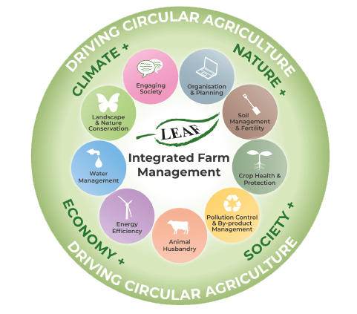
Figure 1 - The 9 key areas of Integrated Farm Management

IFM is a circular approach based on sustainable intensification and soil regeneration principles. It is based on nine key areas, which together address the entire farm business. Each of the nine sections is interrelated and an understanding of how they work together is essential for the effective implementation of IFM. Attention to detail is key; appropriate and efficient use of inputs, smarter approaches to business planning and the adoption of innovations and new technologies, all contribute to increasing productivity whilst protecting valuable resources.

Agroecology

Agroecology is an integrated approach that simultaneously applies ecological and social concepts and principles to the design and management of food and agricultural systems. It seeks to optimise the interactions between plants, animals, humans and the environment while taking into consideration the social aspects that need to be addressed for a sustainable and fair food system.

Agroecology is not a new invention – the term has been used in scientific literature since the 1920s (Wezel, 2009). More recently, agroecology has become a popular concept in international and UK agricultural discourse.

It is fundamentally different from the key resource-based approaches to sustainability. Agroecology is based on bottom-up and territorial processes, helping to deliver contextualised solutions to local problems. Agroecological innovations are based on the co-creation of knowledge, combining science with the traditional, practical and local knowledge of producers. By enhancing their autonomy and adaptive capacity, agroecology empowers producers and communities as key agents of change. Rather than tweaking the practises of unsustainable agricultural systems, agroecology seeks to transform food and agricultural systems, addressing the root causes of problems in an integrated way and providing holistic and long-term solutions. This includes an explicit focus on social and economic dimensions of food systems. Agroecology places a strong focus on the rights of women, youth and indigenous peoples.

Agroecology embraces all that we must do. It’s deep. It’s a movement. It has global meaning. It encapsulates organic, holistic, and regenerative practises and principles.

So why has it not taken off like regenerative agriculture? Arguably, it has, as it underpins and includes all the good work that is now happening. The future is an agroecological one. But as a brand, as a concept, it doesn’t quite fly in the farm office, marketing department or boardroom whereas regenerative thinking seemingly does.

The Oxford Real Farming Conference – The Home of Agroecology

In the UK, the home of agroecology is The Oxford Real Farming Conference (ORFC). It was started in 2010 by Colin Tudge and Ruth West (founders of the Campaign for Real Farming) and agricultural writer Graham Harvey, to highlight the alternatives to conventional farming and to offer all farmers a different kind of farming conference. This event has helped build the narrative and momentum for the transition we see today.

It has developed over the last twelve years to become the unofficial gathering of the agroecological farming movement in the UK, including organic and regenerative farming, bringing together practising farmers and growers with scientists and economists, activists and policy-makers every January. Working with partners such as the Land Workers Alliance and Pasture Fed Livestock Association, the conference offers a broad programme that delves deep into farming practises and techniques as well addressing the bigger questions relating to our food and farming system. Its radical and inclusive programme is suggested and developed by its delegates.

ORFC is now branching out, running ‘in the field’ events in the summer at venues such as FarmED and Groundswell at Wakelyns Farm.

Modern Practitioners, Voices and Mentors

It would be remiss to explore the regenerative movement without briefly noting the impact of some (and there are many more) of the most well-known farming practitioners, advisers, and mentors across the globe.

North America is without doubt the stronghold of the modern regenerative farming hero. The movement has been inspired and popularised by a range of muddy boots farmers and story tellers including the self-proclaimed ‘lunatic farmer’ Joel Salatin (Polyface Farms), Gabe Brown (Browns Ranch) and Will Harris (White Oak Pastures). Soil food web guru Dr. Elaine Ingham and Ray Archuleta lead the debate on soil biology while John Kempf (entrepreneur, speaker and educator) builds the narrative for investing in regen ag.

Australian Darren Doherty, following P.A Yeomans’s keyline concepts, coined the term ’Regrarian’ to describe those who are actively undertaking the serious and timely process of regenerating, restoring, rehabilitating, rekindling and rebooting production landscapes. Doherty's Regrarians Platform, based on the Keyline Scale of Permanence, is the basis of his consultancy and outreach work. Fellow Australian, Dr Christine Jones, is famed for her work on soil and carbon. Nicole Masters is a New Zealand agroecologist and author of For the Love of Soil: Strategies to Regenerate Our Food Production Systems. She is known for her often humorous approach to soil and is one of the influential women behind the regen ag movement.

A leading light in Europe is French farmer and conservation agriculture champion Frederic Thomas. In 1999 Frederic launched the specialist magazine “TCS” focused on minimum tillage and then supported the creation of BASE in the UK.

Dr Vandana Shiva (Figure 2) is an Indian scholar, environmental activist, agroecological and food sovereignty advocate, ecofeminist and anti-globalisation author. Based in Delhi, Shiva has written more than 20 books and is often referred to as "Gandhi of grain" for her activism associated with anti-GMO movement.

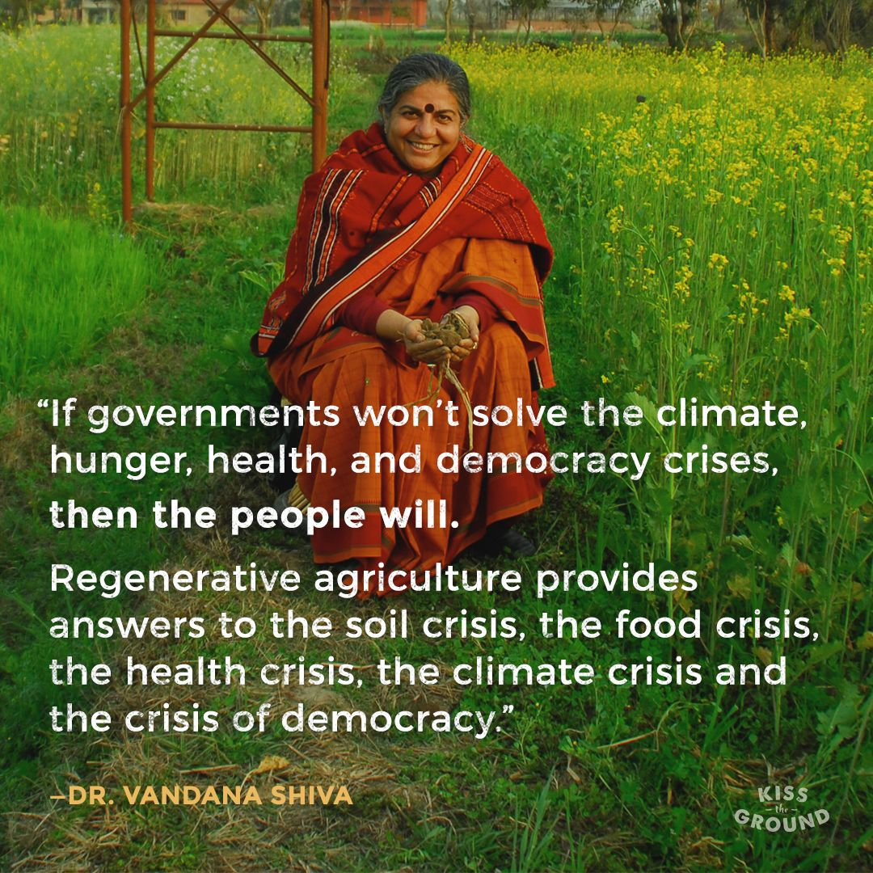
Figure 2 - Quotation from Dr Vandana Shiva.

Who are the leaders in the UK? Satish Kumar, Philosopher, Editor Emeritus of Resurgence & Ecologist and founder and director of Programmes of the Schumacher College deserves a mention, as does HRH Prince Charles for his work on sustainable farming and concepts of harmony. Patrick Holden, organic farmer and founding director of the Sustainable Food Trust, works tirelessly across the sector. We should also note the good work at some of our more forward thinking academic and research establishments such as the Centre for Agroecology, Water and Resilience at Coventry University and FAI Farms.

“More than ever people around the world are rising to the challenge and realising that we are facing a climate catastrophe” Satish Kumar (2021).

But who are our muddy boots heroes? This is harder to pin down - we are not so good at celebrating our farmers here it seems, but champions such as Tim May (Kingsclere Estate, Hampshire), Jake Freestone (Overbury Estate, Gloucestershire), Ed Horton (SS Horton & Sons, Gloucestershire), George Young (Fobbing Farm, Essex), Tim Parton (Brewood Park Farm, Staffordshire) and The Cherries (Lannock Manor Farm, Hertfordshire) are all adding to the regenerative discourse and proving it can be done. We now need more!

The who’s who of regenerative agriculture will be developed further in GREAT Paper Two and Three.

Regenerative Agriculture Goes Mainstream – The Gabe Brown Effect

As the pressure mounts for deep change, the discourse around regenerative agriculture has flourished of late. The work of the early pioneers is, it seems, now playing out. Gabe Brown is one of the pioneers of the modern regenerative agriculture movement and a current leading light.

Gabe, with his wife Shelly and son Paul, own and run Brown’s Ranch, a diversified 5,000 acre farm near Bismarck, North Dakota. The ranch consists of several thousand acres of native perennial rangeland, perennial pasture and arable land. They focus on farming and ranching in nature’s image showing that healthy soil can lead to clean air, clean water, healthy plants, thriving animals, and happy people.

The Browns holistically integrate their grazing and no-till cropping systems, which include a wide variety of cash crops, multi-species cover crops along with grass-finished beef and lamb. They also raise pastured laying hens, broilers and pigs. Their diverse approach, over 20 years, has regenerated the farm without the use of synthetic fertilisers, pesticides or fungicides.

Have you read “Dirt to Soil, One Family’s Journey into Regenerative Agriculture” yet? Gabe’s book (Figure 3), published in 2018 by Chelsea Green Publishing was a lockdown must, and is partly responsible for the current regen rush.

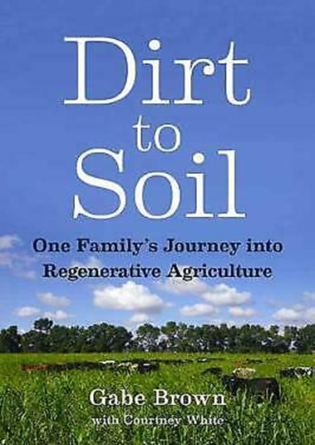
Figure 3 - ‘Dirt to Soil, One Family’s Journey into Regenerative Agriculture’

In Dirt to Soil, Gabe identifies the five key principles of regenerative agriculture (see Table 1). These are summarised below (amended with some additional info from Groundswell website and FarmED team).

The Five Principles of Regenerative Agriculture
- Do not disturb the soil
Soil supports a complex network of living organisms, roots, worm-holes, fungal hyphae and a labyrinth of microscopic air pockets surrounded by aggregates of soil particles and exudate. Disturbing this, by ploughing or heavy doses of fertiliser or sprays will set the system back. Therefore:

- Allow living soils to thrive
- Adopt zero/minimum tillage
- Reduce chemical intervention
- Use more perennial crops

- Keep the soil surface covered
The impact of rain drops or burning rays of sun or frost can harm the soil. Wind and water can wash it away. A duvet of growing crops, or stubble residues, will protect it. Therefore:

- Use cover crops between crops
- Undersow a living mulch or your next crop
- Don’t remove all your straw and crop residues

- Promote living roots all year
Living roots in arable and grassland soils are vital for feeding the creatures at the base of the soil food web; the bacteria and fungi that provide food for the protozoa, arthropods and higher creatures further up the chain. They also keep mycorrhizal fungi alive and thriving and these symbionts are vital for nourishing most plants and will thus provide a free fertilising and watering service for crops. Therefore:

- Use more deep rooting perennial cropping
- Don’t overgraze – use mob grazing, rest and holistic management techniques
- Feed the roots – use bio stimulants, manures, composts, mulches etc.

- Grow a diverse range of crops
Monocultures do not happen in nature - our soil and wider ecosystem thrives on complexity and variety.

- Develop long and diverse rotations
- Use diverse crops and mixes within the rotation
- Consider companion cropping e.g. vetch and clover in OSR
- Think upwards too – agroforestry can bring many benefits in a diverse system

- Integrate grazing livestock into the system
You can be regenerative without livestock…but it’s better with. The sun shines, it rains, green stuff grows. Photosynthesis powers the system. Diverse grassland feeds the soil, sequester carbon, provides an arable break and is great for wildlife. Livestock cycle the nutrients, stimulate the soil ecosystem, and turn sunlight into nutritious protein. Therefore:

- Value your species rich permanent pastures
- Include herbal leys diverse rotations
- Utilise green arable covers
- Promote nutrient cycling and stimulation of a living soil
- Introduce mob grazing, bale grazing etc.

Table 1: The Five Principles of Regenerative Agriculture

Groundswell – The UKs Regenerative Farming Event

Groundswell, now in its sixth year, is a practical farming show and gathering of minds. Curated by the Cherry family and held in June each year at Lannock Manor Farm, it provides a forum for farmers, and anyone interested in food production or the environment to learn about the theory and practical applications of conservation agriculture and regenerative systems, including no-till, cover crops and re-introducing livestock into the arable rotation, with a view to improving soil health (Figure 4). Groundswell is THE regenerative event of the year in the UK - in 2021 it attracted over 3,500 delegates.
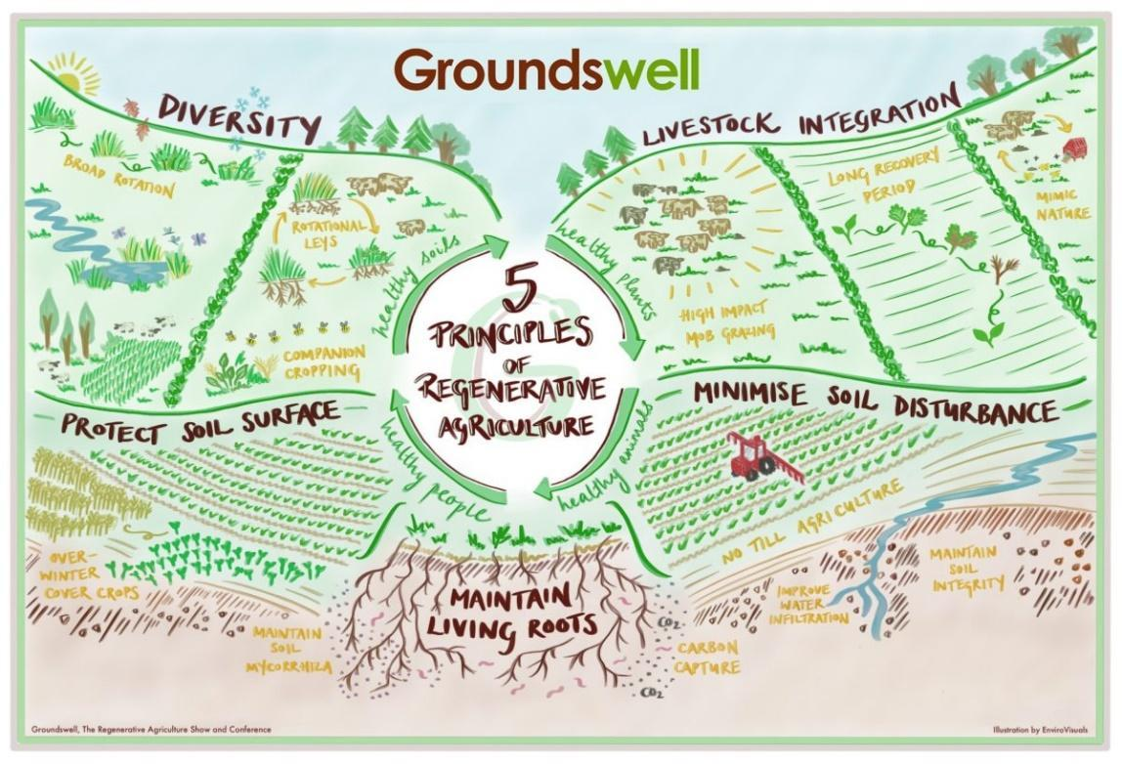
Figure 4 - The 5 principles of regenerative agriculture (from Groundswell)

The Crucial Sixth Principle of Regenerative Agriculture

Importantly, there is an emerging sixth principle within the world of regenerative agriculture. It currently varies between commentators and advocates, but it is focused on holistic considerations and thus potentially takes regen deeper than soil and agronomy. It looks beyond the farm gate.

The sixth principle suggests we should:

- Listen to the land
- Understand your own and the farm context
- Value social outcomes and be accountable

This principle will develop over time as the regenerative movement matures.

Regenerative Agriculture – Building the Definition

Do We Need a Universal Definition?

Despite the term having been used for some time across academic literature, within farming business and environmental organisations, regenerative agriculture does not have a universal definition and standard. Maybe it doesn’t need one? Maybe it is still evolving? Maybe it has held it back? This lack of clarity offers benefits but can also be a hindrance to the regenerative agricultural movement as highlighted in Table 2.

Table 2: Benefits and disadvantages of an open definition for regenerative agriculture
Benefits | Disadvantages
- A regenerative system can be defined as an evolving and holistic mix of principles, practises and outcomes.  - It recognises that in differing climates, environments and soils, different practises can be used to achieve the same goal, or through adopting the same practise, results can occur at different speeds.  - It can flex to suit the farm, farmer or enterprise (the 6th principle), optimising outcomes.  - With the right information and tools, it can be adopted anywhere in the world.  - It grows from the bottom up. | - When the term is used within policy and strategy, the lack of a clear definition can result in lack of depth and/or focus, and ineffective delivery.  - A loose meaning can get lost and corrupted (watered down) over time.  - Regenerative claims can be mis-used, co-opted and overstated in marketing campaigns by farm businesses and associated industries i.e. green wash.  - Consumers may struggle to identify, understand and trust regenerative claims and brands.  - Researchers lack a clear framework or single-issue focus to follow when seeking evidence.

Slow Burn to Take Off

One significant outcome of not having a strict definition has been RA’s slow growth following Rodale’s initial work. It took time to gain traction, seemed too similar and tied to organic agriculture and didn’t offer an attractive market alternative.

But as the need for lower input climate positive systems has grown so has the focus on regeneration. From 2012 to 2019 there was a massive (nearly 5 times) increase in the use of the term in literature and media (Newton et al., 2020). RA gained attention and relevance during this period and took off big time.

Efficiency v Substitution v Redesign - ESR

One useful way of considering the shape and position of regenerative agriculture against other key farming approaches is to place it in a ESR framework (Figure 5), (amended from Hill and MacRae, 1995). This shows the current reach of regenerative agriculture and potential to develop into the food system and redesign paradigms.

Figure 5: Diagram showing the ESR framework with various types of farming at differing scales.
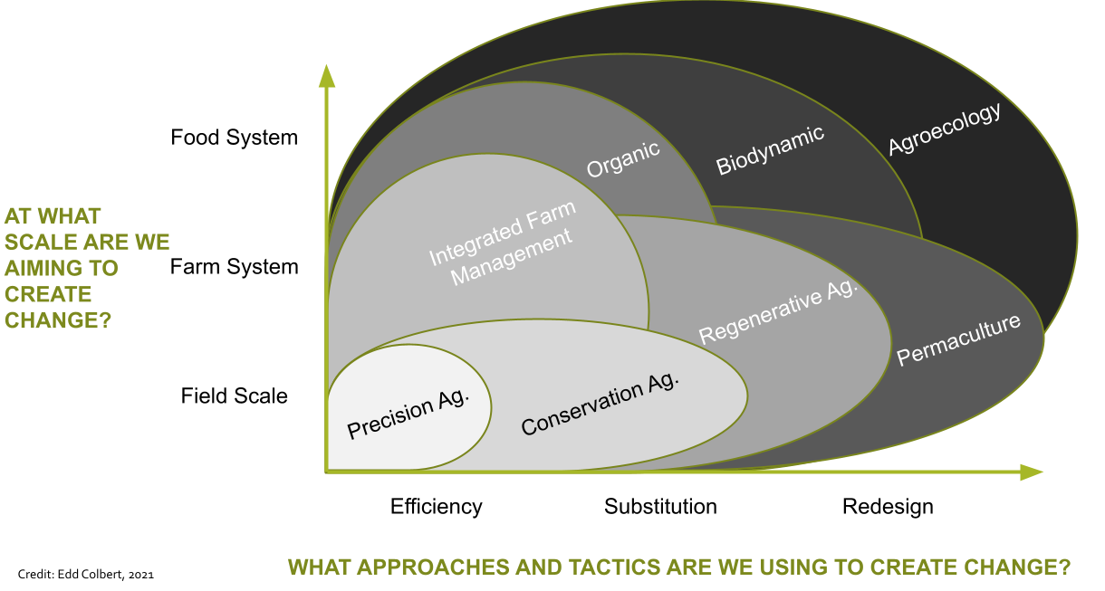

Going to Scale - Moving from Bottom Up to Top Down

Regenerative agriculture was born in the fields and in the hearts of farmers and growers. It has been a bottom-up movement invoking a feeling of hope and empowerment by those learning and practising its art. Until now!

Corporate Shift

While more naturalised farming systems can, and should, cover the planet, regenerative agriculture will only move to scale and dominate with support and power from key supply chain players: food corporations, agri-businesses, tech companies, entrepreneurs, financial institutions, and governments.

By investing in natural capital and the soil, food giants across the globe are seeking to secure more climate resilient commodities produced with less polluting, regulated and expensive inputs. Supporting regenerative farmers follows the neoliberal concept of shared value (Porter and Kramer, 2019) by looking after the chicken they get more and better eggs. They are looking for new marketing claims and premium markets. They are eager to see their Corporate Social Responsibility (CSR) budgets achieving something tangible. They feel a sense of guilt but also seek competitive advantage and new forms of return.

Only scale can bring costs down and increase reach to the point that regenerative food becomes the norm on the supermarket shelf. Investors see value in this shift.

Take a look at the work being done, and investment currently being made, by corporations such as Nestle, General Mills, Danone, PepsiCo, Arla, etc. It is more than CSR and greenwash. It is deeper than boardroom signalling. Regenerative agriculture is the next big thing in the City, and the big guns are now leading the transition.

Regenerative Standards and Marques

How can consumers find and trust regenerative products? Currently, options are limited. A minority can buy directly, question their local farmer, and see their work and soil first-hand but this will not lead to scale.

What is on the supermarket shelf? In the UK we can turn to the leading organic and biodynamic assurance schemes (Soil Association, OF&G, Demeter etc.) and the Pasture for Life marque run by the Pasture Fed Livestock Association. The LEAF marque has good market share and is growing. But do these marques truly equal ‘regenerative’?

In the US there are several industry standards and marques focused on regenerative. These marques include:

- Regenerative Organic Certified - a Rodale-led certification for food, textiles, and personal care ingredients
- Certified Regenerative - by A Greener World
- Land to Market - Ecological Outcome Verification led by the Savory Institute.

A Greener World and Land to Market are building in the UK as we speak. International supply chain verification and farm assurance could also be sought via Control Unions’ new Regenagri® programme. These marques remain niche, however, but with exciting growth potential.

Watch this space – there are more marques and standards on the horizon…

The Carbon Trade – The New Wild West?

One important outcome, and driver, of a regenerative farming approach is the increase in soil carbon. As well as leading to enhanced low input production and profit, soil carbon is a valuable and tradable asset. As countries, companies and individuals seek to reduce their carbon emissions and offset their footprint. Those that can sink and sequester (i.e. farmers and foresters) can look to benefit.

But it’s the wild west out there! There is a growing and confusing plethora of carbon offset providers developing audit schemes, trading platforms certification standards, pricing and advice packages. Blended finance is exciting but the market is unregulated and volatile. We don’t have a much-needed soil carbon code in the UK to work to – yet.

No doubt, this sector will grow and mature and help drive the regenerative transition faster and at scale. But buyer and seller beware!

Final Thoughts: Policy is Catching Up

Regenerative farming in the UK has grown in popularity, bottom up, despite Government policy. But maybe the policy environment is now driving the transition? Declining direct payments must equal lower-input farming.

As we write this paper, Defra is releasing more details about the future of farm support in England. We will move to a ‘public money for public goods’ system based on environmental outcomes. There are positives in view, including payments for soil assessment, cover crops and diverse herbal leys. Good news for sure.

But will the future foster system and mind set change? Will it be truly regenerative? Will it be closer to sustainable intensification with patches of rewilding? Time will tell…

Written for The GREAT Project by:

Jonty Brunyee – Head of Sustainable Farming and Food Systems (FarmED)
Danielle Semple – Sustainable Farming Intern (FarmED)

December 2021

References

Deans, Z. (2020) ‘What is regenerative agriculture?’, Greenpeace. Available at: https://thrivemarket.com/blog/what-is-regenerative-agriculture%0Ahttps://www.greenpeace.org/new-zealand/story/what-is-regenerative-agriculture/.

FAO Food and Agriculture Organisation of the United Nations, 2012. Available online at http://www.fao.org/ag/ca/6c.html.

Harwood, R.R., (1983). International overview of regenerative agriculture. Rodale Research Centre.

Hill S.B., MacRae R.J. (1995). Conceptual framework for the transition from conventional to sustainable agriculture. Journal of Sustainable Agriculture. 7:81-87.

Howard, A. (1947) The Soil and Health: A Study of Organic Agriculture, University Press of Kentucky, Kentucky.

Newton, P. et al. (2020) ‘What Is Regenerative Agriculture? A Review of Scholar and Practitioner Definitions Based on Processes and Outcomes’, Frontiers in Sustainable Food Systems, 4(October), pp. 1–11. doi: 10.3389/fsufs.2020.577723.

Porter M.E., Kramer M.R. (2019) Creating Shared Value. In: Lenssen G., Smith N. (eds) Managing Sustainable Business. Springer, Dordrecht.

Ravenscroft, N., Moore, N., Welch, E., and Hanney, R. (2013). Beyond agriculture: the counter-hegemony of community farming. Agric. Hum. Values 30, 629–639. doi: 10.1007/s10460-013-9437-7

Rhodes, C. J. (2017). The imperative for regenerative agriculture. Sci. Prog. 100, 80–129. doi: 10.3184/003685017X14876775256165

Rodale R, (1987) Res. Issues Related to Strategic Planning U. S. Agric. Glob. Setting Proc. Minutes Thirty-Sixth Annual Meeting. Agric. Res. Inst. Oct. 7-9 1987 Wash. DC (Agriculture Research Institute (U.S.).

Van Seijen, K., (2021). Be humble, you can’t outsmart nature. [podcast] Investing in Regenerative Agriculture, Food and Farming. Available at: <https://investinginregenerativeagriculture.com/2021/11/16/satish-kumar/> [Accessed 13 December 2021].

Wezel, A. et al. (2009) ‘Agroecology as a science, a movement and a practice’, Sustainable Agriculture, 2, pp. 27–43. doi: 10.1007/978-94-007-0394-0_3.

Yeomans, P.A., 1958. The challenge of landscape: the development and practice of Keyline. Keyline Pub. Pty.

